ECA3101-NANO ELECTRONICS
Exp. 4. Kronig Penney Model
TEST CASE-1: Triangular well
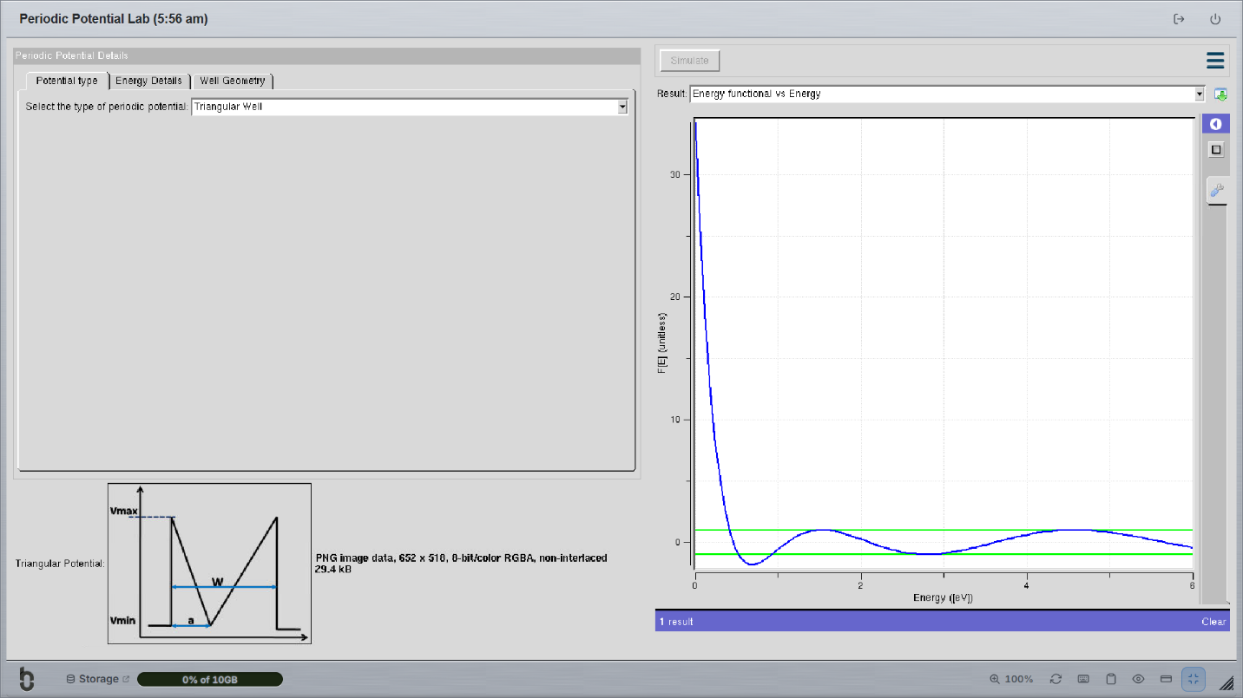
TEST CASE-2: Sinusoidal Potential


